REPORT ON SEX WORKERS
Reporting by Venkatesh Kodukula
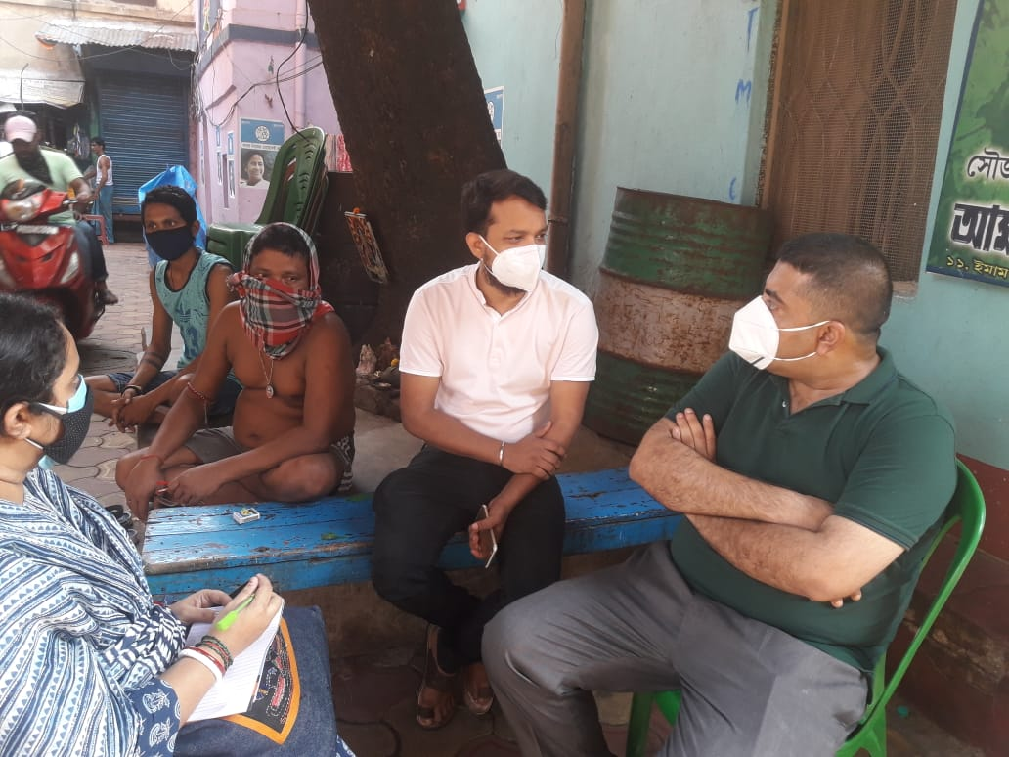

TABLE OF CONTENTS
Introduction……………………………………………………………......3

Observation.......................................................................4

Team Members……………………………………………………………..4

Interviewees List.....................................................................4-5

Plan of Action….............................................................................5

Picture Gallery.............................................................................6--8

INTRODUCTION
Sonagachi is a neighbourhood in Kolkata, India, located in North Kolkata near the intersection of Jatindra Mohan Avenue (north of C.R. Avenue) with Beadon Street and Sovabazar, about one kilometer north of the Marble Palace area.
Sonagachi is the largest red-light district in Asia with several hundred multi-storey brothels and an estimated 7,000 sex workers (2020) contained within the area.
Several NGOs and government organizations operate in Sonagachi for the prevention of sexually transmitted diseases (STD) including AIDS. The book Guilty Without Trial by the founders of the NGO Sanlaap based much of their research into human trafficking in India on this area.

Sonagachi
Neighbourhood in Kolkata (Calcutta)
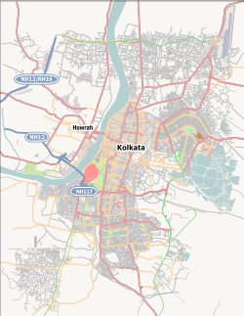
Sonagachi
Location in Kolkata
Coordinates: 22°35′15″N 88°21′35″ECoordinates: 22°35′15″N 88°21′35″E
Country | India
State | West Bengal
City | Kolkata
OBSERVATION

Date of Survey- May 15th,2021

Time-3-5pm

Location- Sonagachi,Kolkata

Team Members- Advocate Sandipan Das, Advocate Soumitra Karmakar Chakraborty and Advocate Sabyasachi Chatterjee.

As we are going through such unprecedented times, lot of people have been facing issues in terms of their livelihood and Sex Workers are one of the major hit ones. There has always been a social taboo and discrimination against them irrespective of any gender.

Survey was conducted with forty sex workers. They mentioned that because of the ongoing pandemic and the partial and full lockdown, they are not getting clients as before. They mentioned that though they have applied for digital ration cards but some haven't received them yet which is a major violation to their fundamental right. One of the other major issues which they highlighted was that they are not being able to pay their monthly house rent and other bills due to low income/no income which is turn they are being forced to leave the house premises by the owners.

Underneath are the names of some of the sex workers who has been interviewed.

Serial number | Name of the sex workers | Work Experience(in years) | Work place
 | Manika Rajbanshi | 25-27 | Sonagachi
 | Lata Ghosh | 40-50 | Sonagachi
 | Jaya Halder | 50 | Sonagachi
 | Sandhya Ghosh | 15 | Sonagachi
 | Asha Das | 12 | Sonagachi
 | Lovely | 8 | Sonagachi
 | Trisha Roy | 10 | Sonagachi
 | Noorjahan Bibi | 20 | Sonagachi
 | Usha Paul | 30 | Sonagachi
 | Gita Das | 20 | Sonagachi
 | Lipika Biswas | 15 | Sonagachi
 | Ratna Das | 10 | sonagachi
 | Mongola Baguli | 15 | Sonagachi
 | Ratna Sardar | 15 | Sonagachi
 | Namita Das | 10 | Sonagachi
 | Supriya Sarkar | 10 | Sonagachi
 | Sathi | 12 | Sonagachi
 | Mantu | 15 | Sonagachi
 | Maya Das | 20 | Sonagachi
 | Nupur Biswas | 15 | sonagachi
 | Moni Mukherjee | 13 | Sonagachi
 | Kajal Khatun | 25 | Sonagachi
 | Sikha Mondal | 25 | Sonagachi
 | Chobi Mondal | 20 | Sonagachi

PLAN OF ACTION

We are going to file a Public Interest Litigation regarding monthly basis financial assistance to sex workers in the state of West Bengal and proper food and ration is available to them.. There should be a scheme recognising their work.

Picture Gallery

